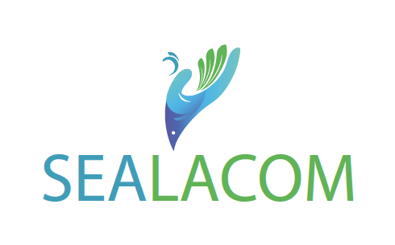
Call for Proposals for Young Researchers

The Call is open to Researchers in all fields of knowledge with a particular attention to projects related to the multidimensional crises that Lebanon is passing through with a focus on resilience, water-energy-food nexus; early warning and risk mitigation; and marine environment, in order to increase resilience of the Lebanese community.
  - Expected date of the project’s end: mid-March 2024.
  - Eligibility conditions for participation: Young Lebanese researchers affiliated to the main research institutions in Lebanon (CNRS centres, Universities and Research centres) with an Italian partner affiliated to any research institution in Italy.
  - Budget of Each Project: 4,500 € to be used mainly to cover mobility from Lebanon to Italy and implementation Costs for the project.
- Deadline for application: October 16, 2023
- Complete application should be emailed to enjeim@cnrs.edu.lb ; imane.abbas@cnrs.edu.lb with the subject line “SEALACOM-Researchers-mobility”

PROPOSAL / APPLICATION FORM

Title in English

Main Investigator in Lebanon (Please Attach Curriculum Vitae in .pdf format)
Name
Surname

Title

Function
Affiliation
Phone number

Email
Main Investigator in Italy (Please Attach Curriculum Vitae in .pdf format)
Name

Surname

Title

Function

Affiliation
Phone number

Email

Total number of persons involved in the project
Number of women involved in the project
Number of youth involved in the project (below 35 years) :
Others:

Objectives
Research proposal (max. 2 pages)
Timeline

Activity | M1 | M2 | M3 | M4 | M5 | M6
Final Report

Budget Breakdown:
Budget line | Amount in Euros
TOTAL | 4500 euros

Requirements for justification if the project is accepted:
- Copy of ticket and boarding pass
- Summary of mission executed in Italy following Annex 1
- Invoices and other proof for implementation costs

Annex 1

Mission Report
Name of the Travelling Person
Name of the Project
Travel Dates (From-To)
Destination | Where in Italy did you travel  (Ex. Rome/Bari/Sienna/Other (please specify)
Receiving Institution
Objective
Brief Description of the Mission

Budget of the Mission
Ticket Costs (Economy class)  (Attach Ticket, Invoice & Boarding Cards) | Max 900 euros for Economy Class ticket
Accommodation and Meals Costs | Max 150 euros per night to be justified by invoices according to the number of days justified for the mission
Travel Insurance | Covering the duration of the mission
Signature

